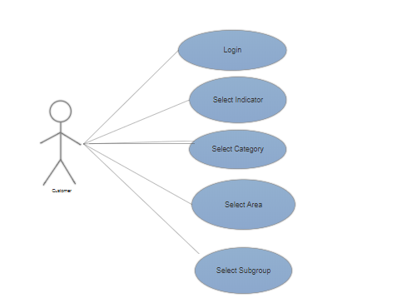

Figure1: Use case diagram for provider

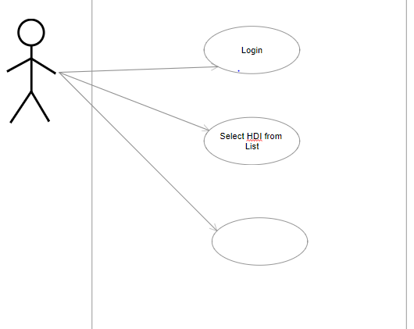

Analyze Data

Figure 2: Use case diagram of consumer

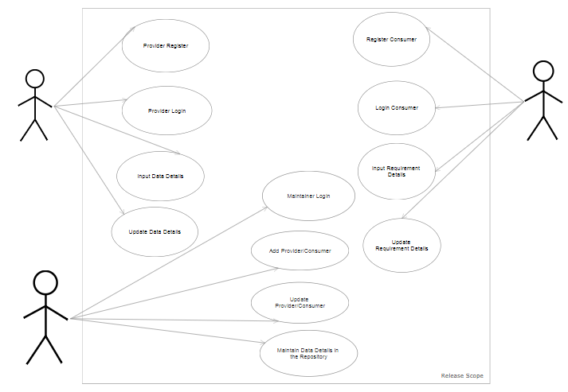

Figure3: Use case diagram of Maintainer

**BOOKS AND REFERENCES**

**WEBSITES:**

* <https://en.wikipedia.org/>
* <https://www.w3schools.com/html/>
* <https://stackoverflow.com/>
* <https://nodejs.org/>
* <https://d3js.org/>

**BOOKS:**

* Node Up and Running - Tom-Hughes Croucher
* The Node Book – Manuel Kiesling
* HTML & CSS: Design and Build John Duckett

**Contents**

Page No.

1. List Of Figures
2. Introduction
3. Project Analysis
4. Project Design
5. Screenshots
6. Code Snippet

**LIST OF FIGURES**

**Use Case Diagram**

A use case diagram is used to model and identify the functional

requirements of a software system. In a use case diagram, stakeholders and user goals are represented by actor and use cases respectively.

An actor is any person or external system that interacts with the system to achieve a user goal. The Use Case Diagram is a visualization of a use case. The Use Case Diagram for the actions that the Users (provider, maintainer and consumer) can perform in the system. Figure1 shows the use case diagram of provider, Figure 2 is the use case diagram of maintainer and Figure3 shows the use case diagram of consumer.